**IV. Testing**

1. **Testing Steps**

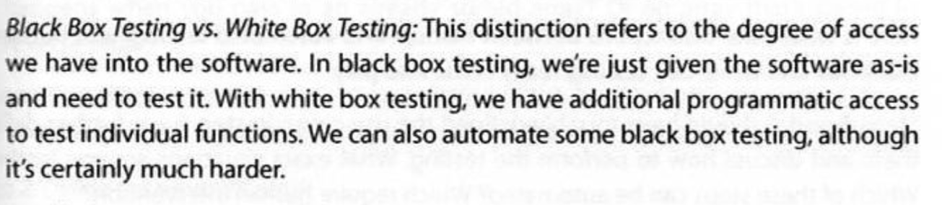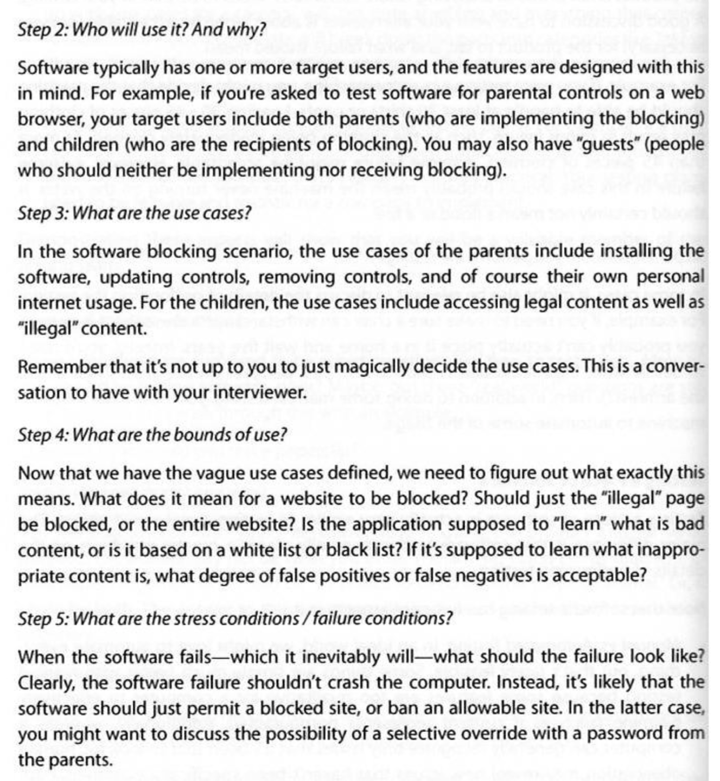

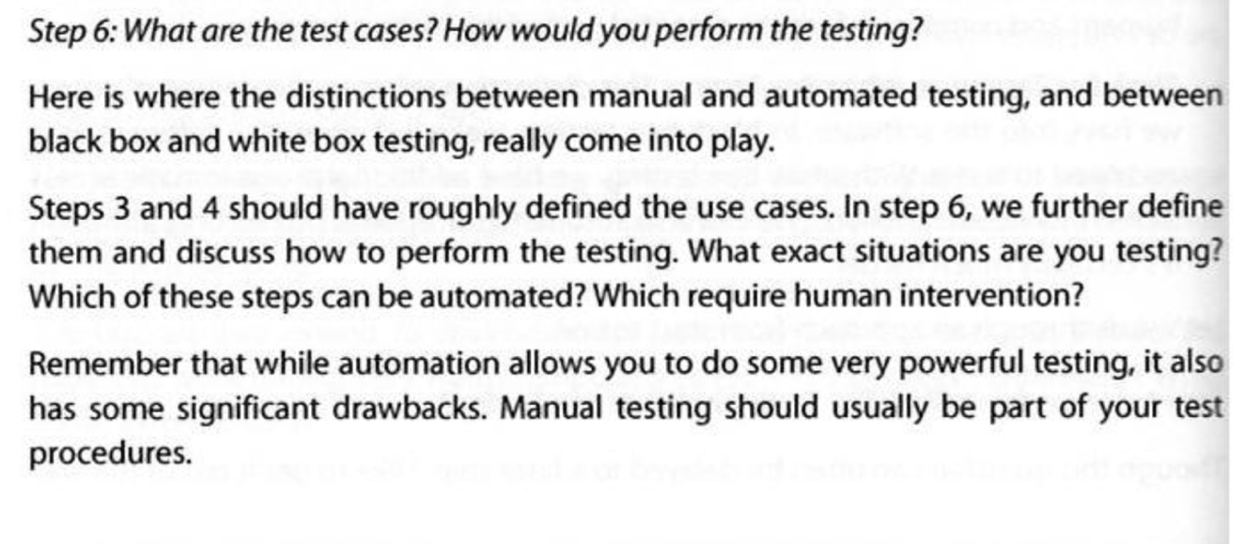

1. **Junit**

* **Test-Driven Development**
* JUnit tests are often used with Test-Driven Development (TDD).
* The process of TDD is to perform short, iterative loops (fail -> pass)
* **The life cycle of a JUnit test**
* Execute order
* @BeforeClass
* Constructor
* @Before
* @Test
* @After
* @AfterClass
* @Before is executed before each test, while @BeforeClass runs once before the entire test
* The order in which the @Before, @After, and @Test methods run is not guaranteed
* This is the heart of JUnit: Your tests should be independent and atomic
* **Assert Class**
* One of the core classes in the JUnit library is the Assert class

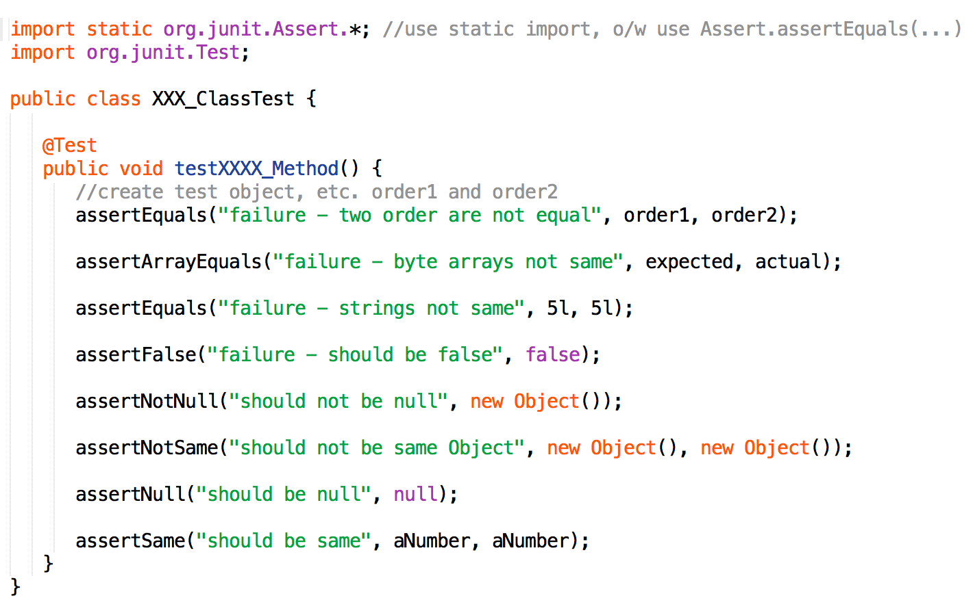

* **Test Expecting Exceptions**
* If the assertion does not hold, an exception is thrown.
* Unless that exception is expected, or caught, that exception will fail the JUnit test.

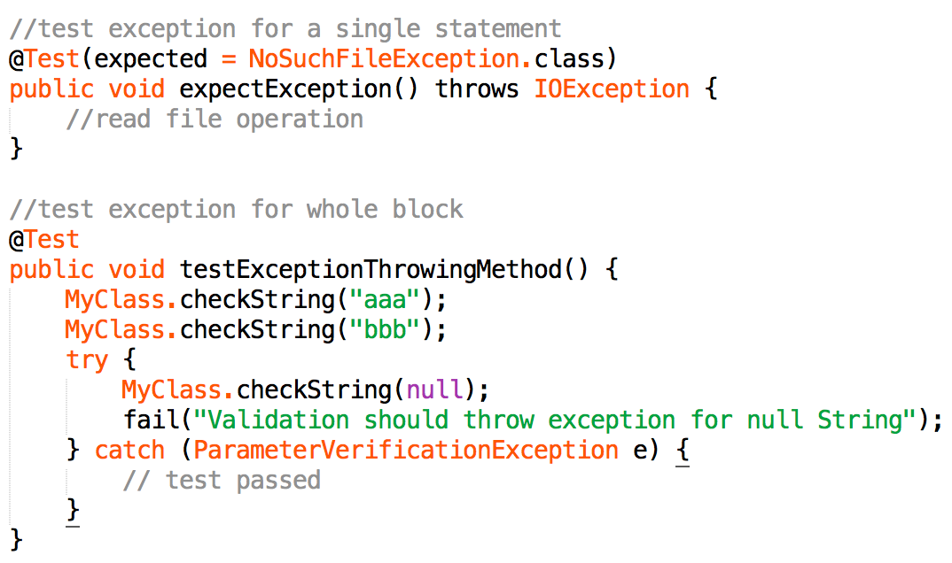

* **Test Time Out**
* The number of timeout represents milliseconds
* If the test is running for longer than that time, the test fails.

